Canterbury Maps User Stories

Template

Guide:
- Please attach separately (within an email) all images so they can be loaded into our website as a separate file. These need to be of a reasonable quality to be displayed on a website.
- Pictures demonstrating the actual use in action are valuable to the community and help sell the story of how your organisation uses the service in relation to your own work. Pictures of i.e.
  - maps produced using our data
  - datasets derived from our data
  - analysis undertaken from our data
  - web applications or mobile applications using our data or derived data
- Once this word document is received we will load this user story into our test area for you to view and approve. This is located here http://test.canterburymaps.govt.nz/

<INSERT LOGO HERE> | Company size: XXX  Founded: XXXX  Most useful service: XXXX  Most useful map: XXXXX  Website: XXXXXX  Industries work within: XXXXX.

How we use Canterbury Maps?

<INSERT TEXT HERE>
<INSERT PICTURE(S)>

Who are we?

<INSERT TEXT HERE>
<INSERT PICTURE(S)>

Example

Company size: 95
Founded: 1932
Most useful service: Canterbury Maps Data, Resource Consents and Monitoring, Groundwater
Most useful map: Christchurch Aerial Photography, Consented activities, Wells and Piezometeric Contours
Website: eliotsinclair.co.nz
Industries work within: Land development, residential and commercial construction, environmental and surveying.

How we use Canterbury Maps?
Our geotechnical engineering team at Eliot Sinclair frequently use ECans’s GIS mapping system to review Well log records to identify underlying geology and to assess the depth of groundwater.
Historical aerial photographs shown on the GIS are also used to determine site history which is useful for our civil and geotechnical engineers, and for the environmental engineers when assessing any risk of contamination.
The GIS mapping system is also helpful in Identifying Consented Activities and is commonly used by our planning team.
In summary, the information shown on Ecan’s GIS is a valuable resource for Eliot Sinclair’s land development consultants, and can assist in investigation issues for our clients and to keep costs down. 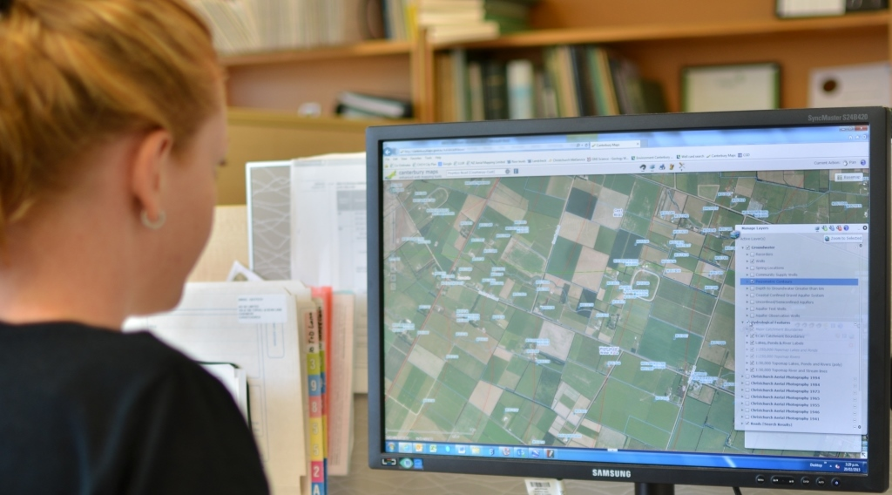
Who are we?
We are a survey, engineering and planning consultancy based in Christchurch, New Zealand. Experienced staff combined with state of the art technology ensures that Eliot Sinclair provide a level of service and a product that is second to none. We specialise in civil and structural engineering, geotechnical and environmental engineering, land development, planning and resource management, hydrographic surveying, cadastral surveying, GPS applications and survey control. To find out more about how Eliot Sinclair can help you with your next project visit us at www.eliotsinclair.co.nz

